Open Heart Extra - Chakras in the Body

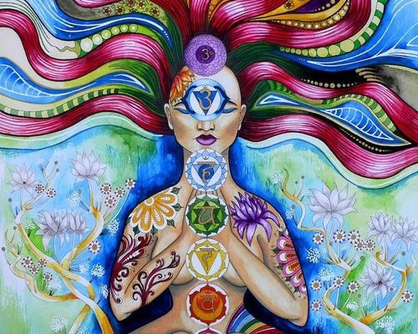

Share this article

Chakras in the Body
Posted January 18, 2013
If you think in terms of chakras, or energy systems in the body or connected with the body, there is the first, second, third, fourth, fifth, sixth and seventh, which are called the muladhara, sradhishthana, manipura, anahata, vishuddha, anja, and sahasrara. The first one is in the bottom of the spine, the second is sort of below the navel, the third is at the navel, the fourth is in the heart region, the fifth is at the throat, the sixth is between the eyebrows, the seventh is on the top of the head. These don’t necessarily have any physiological correlates. They’re just psychic localizations of psychic energy, let’s put it that way, in this Hindu system, a Sanskrit, Hindu system I was talking about. Now, instead of doing an MMPI or a Rorschach you could also do a chakra chart, just like you could do an astrological chart. And these all tell you certain things. An astrological chart is like an MMPI one level back in abstraction. In the same way, a chakra chart tells, in a way, where the energy is fixed or localized in a person, where it’s stuck.
For most people in the Western universe, in fact most people in the world, almost all of the energy is located either in the first, second, or third chakras. The first chakra can be characterized crudely as being connected with survival and the survival of the individual as a separate being. It’s like we’re in the jungle and there’s one piece of meat and who’s going to get it, you or me? It’s a survival-of-the-fittest type model. It’s a Darwinian assumption about the motivations of beings. When you’re at that chakra, your motivation is to protect yourself as a separate being, your separateness. And the channel up which this is all going is called the Sushumna – think of it as a big river. You go in the river from Africa and the next stop is like the Riviera. See, you’ve got your security under control and now you start to go into sensual gratification and sexual desires and reproduction. You can’t be busy reproducing if you’re protecting your life, but the minute your life’s protected a little bit, then you can concern yourself with the next matter, which is reproducing the species. So the second chakra is primarily concerned with sexual actions, reactions, and so on – at the reproduction level. Procreative. Sex.
The third chakra, that’s like Wall Street and Washington and London. It’s primarily connected with power, with mastery, with ego control. Most of the world that we think of is connected with those particular centers. All the energy’s located there. People justify their lives in terms of reproduction or sexual gratification or power or mastery. And it’s interesting that pretty much any act we know of in the Western world can be done in the service of any one of those energies. So that a man can build a huge dynamic industry or we can say, “Aha, phallic,” meaning second chakra. Or a person can seduce many women in order to have mastery and power over them and we say, “Aha, concerned with power and mastery,” meaning third chakra. Doing sex in the service of third chakra.
Jung is primarily concerned with the fourth chakra. I would point out that there are still the fifth, sixth and seventh chakras, and these are in terms of other kinds of psychic spaces and ways of organizing the universe and understanding what’s happening. There are many theories that are nonmystical and there are theories that are mystical; there are theories that deal with transcendent states and there are theories that don’t. And when Jung starts to deal with his archetypes, collective unconscious and so on, he is starting to deal with the fourth chakra, which is the same thing as Buddha’s compassion. He is still in astral planes and he himself is afraid to go on, that’s quite clear. He goes just so far and then he stops, because he’s afraid that if he goes the next step, he will no longer be able to do what he does as Carl Jung. That’s a very tricky place, to be able to surrender to your game which you have certain mastery in, in order to go for more. But I’m afraid that everybody is driven to go for more until they can, in the depths of their inner being, say, “This is enough.” And they can only say that when it is. So the press of evolution on man’s consciousness is inevitable. There’s nothing he can do about it. He doesn’t really have much choice in the matter. He’s just got to wake up at the rate he’s got to wake up.
- Ram Dass, 1970
Related Content
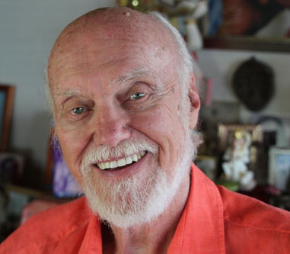
The Paradox of the Body
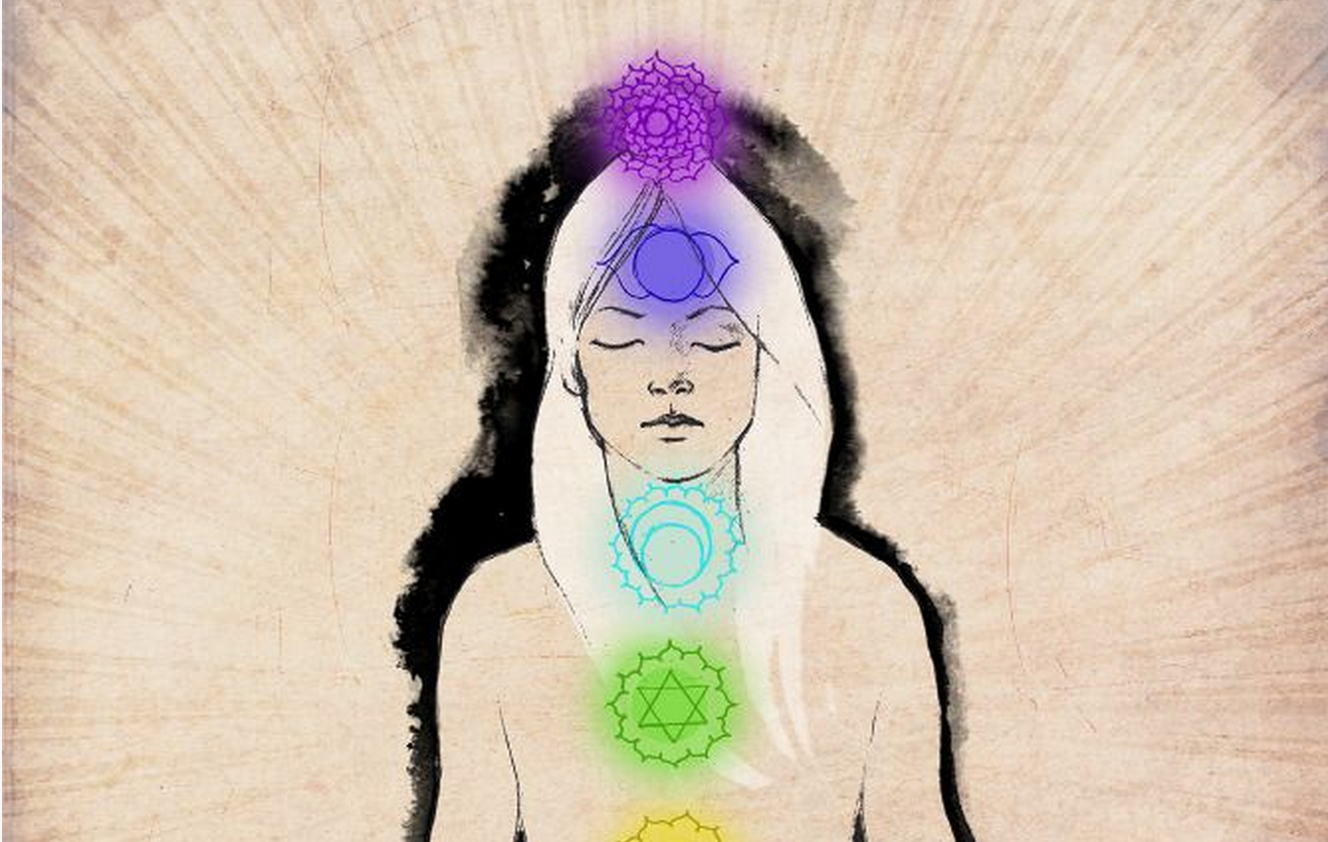
Episode 56: Orgasm & Transcendence
Reflections from Saraswati
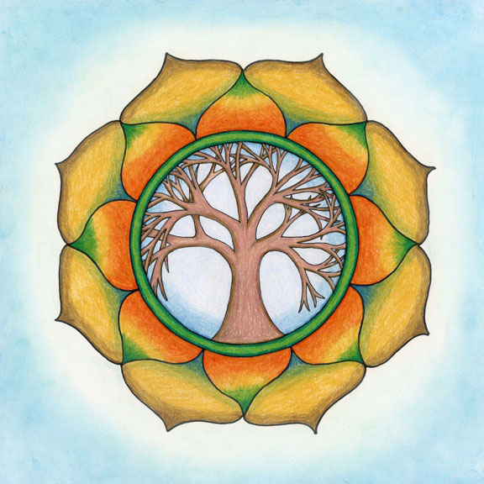
A Tree Isn’t Frightened

